FOR IMMEDIATE RELEASE CONTACT: Jill Midkiff, NASPO
(859) 514-9830
jmidkiff@naspo.org
NASPO supports Make-A-Wish Foundation

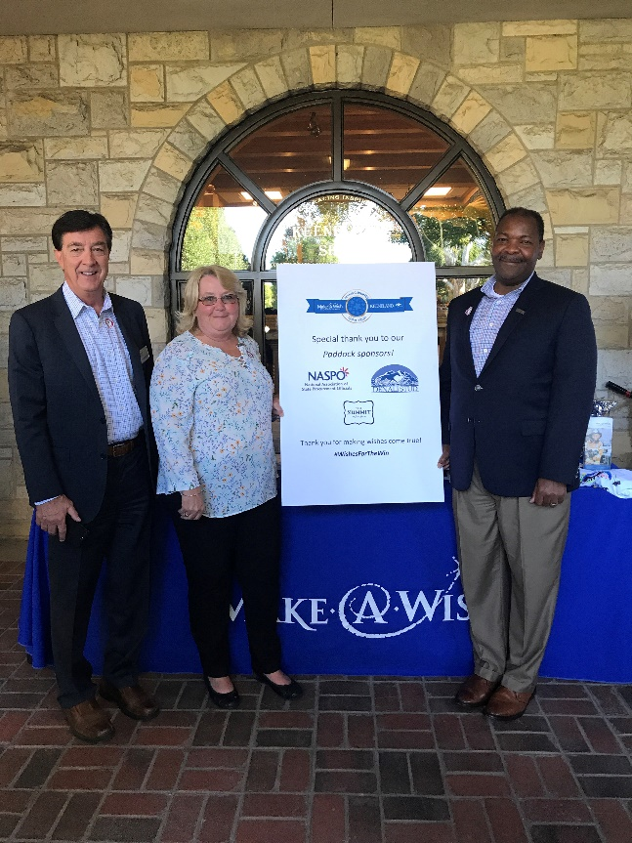
LEXINGTON, Ky. (October 11, 2018)—The National Association of State Procurement Officials (NASPO) is proud to support the Make-A-Wish Foundation of Ohio, Kentucky and Indiana at the 11th annual Make-A-Wish Day, October 11, at Keeneland in Lexington, Kentucky.

Since 2007, the thoroughbred industry and Keeneland have joined forces to grant the wishes of critically ill children in central Kentucky through Make-A-Wish Day. This is the first year NASPO has supported Make-A-Wish with a charitable contribution of $2,000. Through the generosity of regional sponsors, area horse farms and local businesses, Make-A-Wish expects to make the wishes of at least 10 Central Kentucky children a reality.

“As an association representing public servants from across the country, it is nice to be able to give back to the community that is home to our national headquarters,” said NASPO CEO Lindle Hatton.

-30-

NASPO is a nonprofit association dedicated to advancing public procurement through leadership, excellence and integrity. Its membership is comprised of the directors of the central purchasing offices in each of the 50 states, the District of Columbia and the territories of the United States. NASPO helps its members achieve success as public procurement leaders through promotion of best practices, education, professional development, research and innovative procurement strategies.

